**DATA STRUCTURE AND ALGORITHM LAB**

**TIC TAC TOE GAME**

**Project Report By**

**Muhammad Umair.**

**CS-191050**

**3B**

**Group Member:**

**Muhammad Umair CS-191050**

**Hasan Ali Waqas CS-191037**

**Syed Owais Ali CS-191002**

Table of Contents

1. Introduction 3

2. Scope 3

3. Screen Shots 3

4. Task Sheet 3

# **Introduction :**

# The first print reference to "**noughts and crosses**," the British name for the game, appeared in 1864. The first print reference to a game called "tick-tack-toe" occurred in 1884 but referred to a children's game played on a slate. **Tic-tac-toe** have **noughts and crosses** , or **Xs and Os** is a game for two players, *X* and *O*, who take turns marking the spaces in a 3×3 grid. **Tic-tac-toe** game is a paper-pencil game for two players, *X* and *O*, who take turns marking the spaces in a 3×3 grid. Now we can made tic tac toe on console without using paper pencil. We help the players without making the 3×3 grid on paper now players just mark the options.

# **Scope :**

In this project we use the one concept of DSA ( Data Structure And Algorithm ) which is linked list.

**Linked List :**

In linked list further we use singly linked list.

# 

# **Singly Linked List :**

In this project I use singly linked list.

**Algorithms Used In This Project :**

Following are the algorithms used in this project are :

**1. Insert Data.**

**2. Update Data.**

**3. Print Board.**

**4. Check Winner.**

**Language Used In This Project :**

In this project I use c++ language.

**Platform Used In This Project :**

In this project I use Visual Studio Code as platform.

**How To Win Tic Tac Toe Game :**

Tic Tac Toe, also known as *"Noughts and Crosses"* or *"X's and O's"*, is a solved game. This means there is a known, mathematically proven strategy to follow for the best result each game. In Tic Tac Toe, two players who follow the right strategy will always tie, with neither player winning. Against an opponent who doesn't know this strategy, however, you can still win whenever they make a mistake. Once your friends pick up on your strategy, try a more difficult version of the rules.

If you don't know how to play tic tac toe, learn the [basic rules](https://www.wikihow.com/Play-Tic-Tac-Toe).

**Play your first X in a corner :**

Most experienced tic tac toe players put the first "X" in a corner when they get to play first. This gives the opponent the most opportunities to make a mistake. If your opponent responds by putting an O *anywhere* besides the center, you can guarantee a win.

**Try to win if your opponent plays the first O in the center :**

If your opponent plays their first O in the center, you have to wait for them to make a mistake before you can win. If they continue to play correctly, they can guarantee a tie. Here are your two options for your second move, followed by instructions on how to win if they make certain moves (if they don't, just keep blocking their plays and the game will be a tie):

* Place your second X in the opposite corner from your first, so there's a line going "X O X" diagonally across the board. If they respond with an O in one of the other corners, you can win!  Place your third X in the last empty corner, and your opponent won't be able to block you from winning with your fourth X.
* **Or**, place your second X on an edge square (not a corner), *not* touching your first X. If your opponent puts down an O in the corner that's *not* next to your X, you can use your third X to block their move and automatically win with your fourth X.

**Win automatically if your opponent plays his first O in any square besides the center :**

If your opponent puts his first O in any square *besides* the center, you can win. Respond by putting your second X in any other corner, with an empty space in between the two X's.

**Place your third X so you have two possible winning moves :**

Most of the time, your opponent will see that you have two X's in a row and block you. (If not, just win by making a row of three X's.) After this happens, there should be an empty square that is in line with both your first and your second X, with no enemy O's blocking that line. Put your third X in this square.

**Win with your fourth X :**

 After your third X, there are two empty squares that will win you the game if an X goes into one of them. Since your opponent can only make one move, he can only block one of those squares. Write your fourth X into the square he didn't block, and you've won the game!

**Force a draw if the opponent starts in the corner :**

If the opponent plays first and starts with an O in a corner, always put your first X in the center. Your second X should be placed on an edge, *not* a corner, *unless* you need to block your opponent from getting three in a row. Using this strategy, every game should be a draw. Theoretically, you can win from this position, but your opponent would have to make a huge mistake, such as not seeing that you have two X's in a row.

* In this section, your opponent is still playing O's, but remember they get to play first this time.

**Force a draw when the opponent starts in the center:**

When your opponent starts by putting down an O in the center, place your first X in a corner. After that, just keep blocking your opponent from scoring and the game will be a draw.There is essentially no way for you to win from this position, unless your opponent stops trying to win or stop you from winning!

**Try to win if the opponent starts at the edge:**

Most of the time, your opponent will start with one of the moves above. However, if your opponent puts down the first O on an edge, not on a corner or center, you have a small chance to win. Put your first X in the center. If your opponent puts the second O on the opposite edge, making a row or column that reads O-X-O, put your second X in a corner. Then, if your opponent puts the third O in the edge that is adjacent to your X, making a line that reads O-X-O, put your third X in the empty square to block their row of two O's. From here, you can always win with your fourth X.

* If at any point, your opponent doesn't make the exact move described above, you'll have to settle for a draw. Just start blocking their moves and neither of you will win.

**Try these out if your tic tac toe games always end in draws :**

It might be fun for a while to be unbeatable at tic tac toe, but even without this article your friends might figure out how to stop you from winning. Once that happens, every single game of tic tac toe you play with them will be a draw — ugh. But you can still use basic tic tac toe rules to play games that aren't as easily solved. Try them out below.

**Play mental tic tac toe :**

The rules are exactly the same as tic tac toe, but there's no board! Instead, each player says their moves aloud, and pictures the board in their head. You can still use all the strategy advice in this article, but it can be difficult to concentrate on that when you're trying to remember where the X's and O's are.

* Agree on a system for describing moves. For instance the first word is the row (top, middle, or bottom) and the second word is the column (left, middle, or right).

# **5. Screen Shots (attach screenshot of source code and output) :**

**CODE**

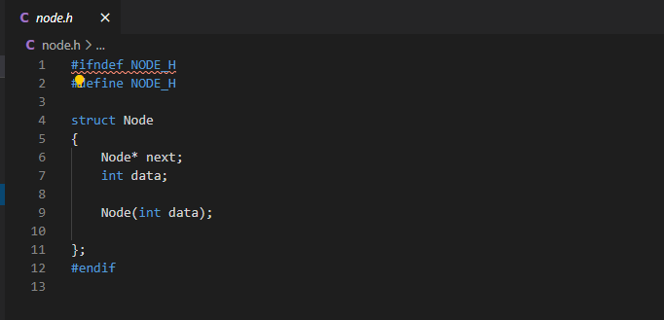

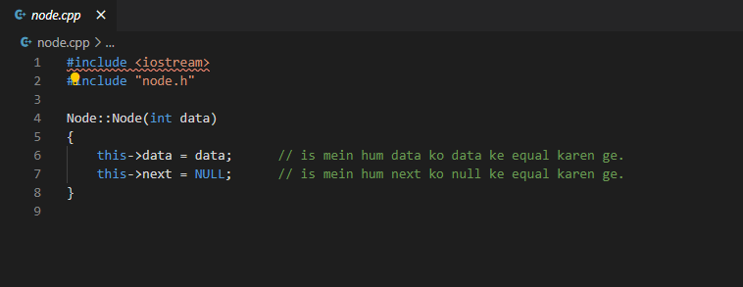

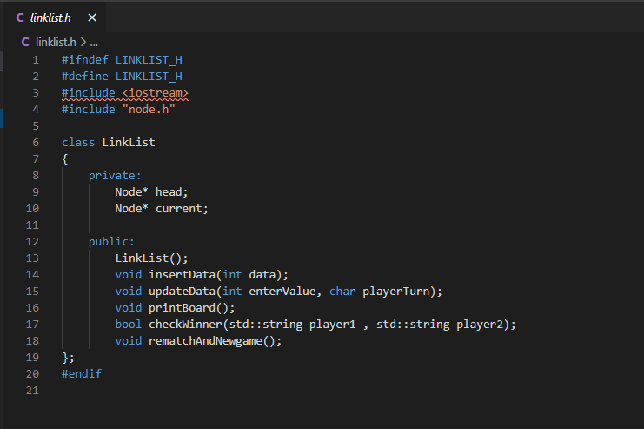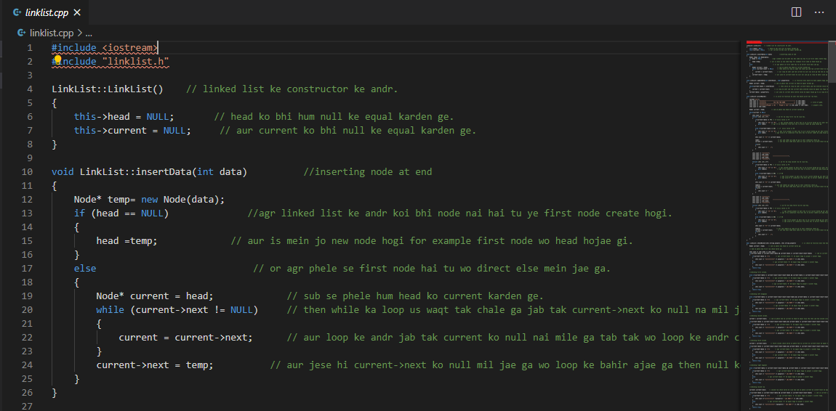

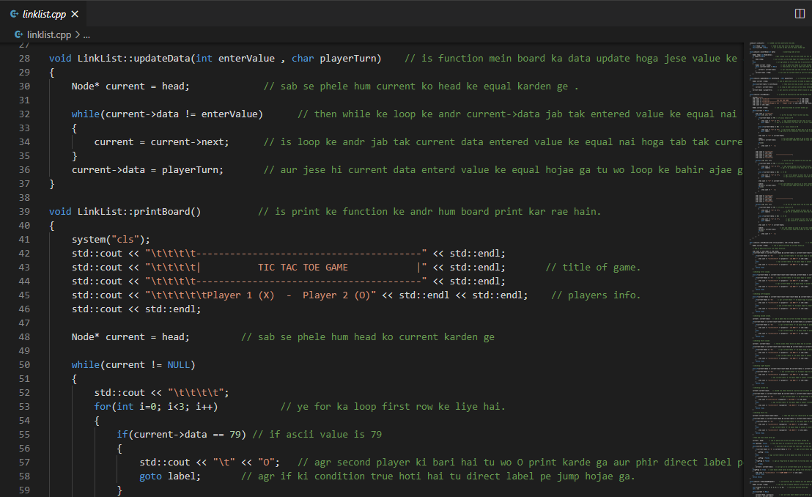

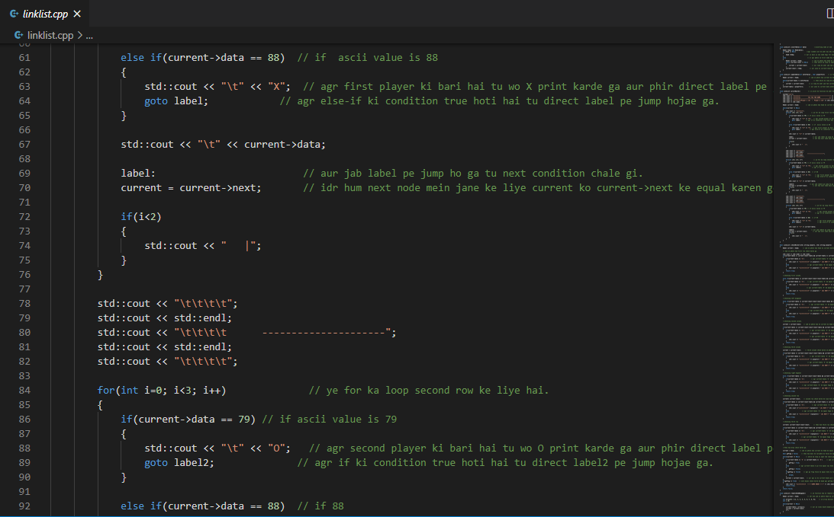

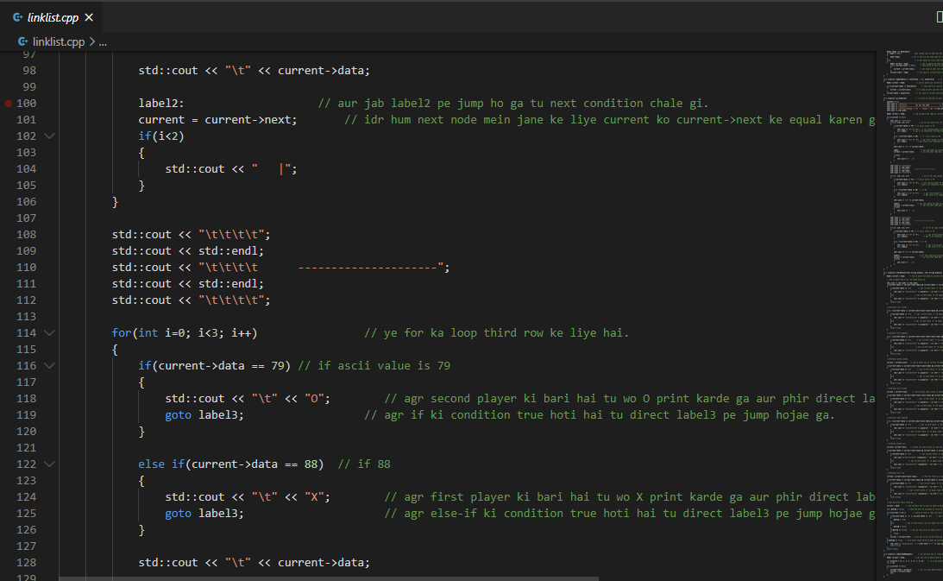

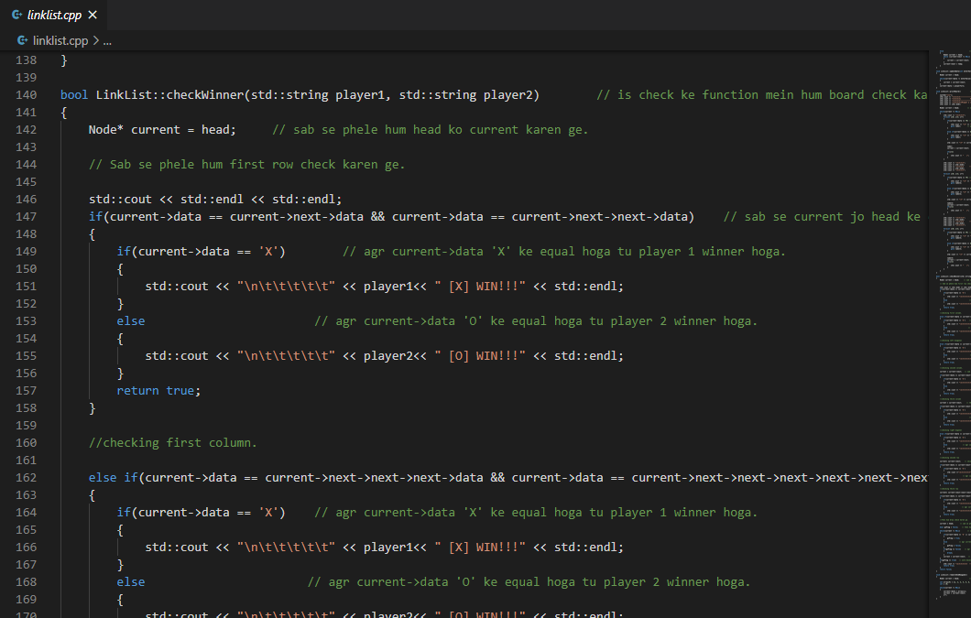

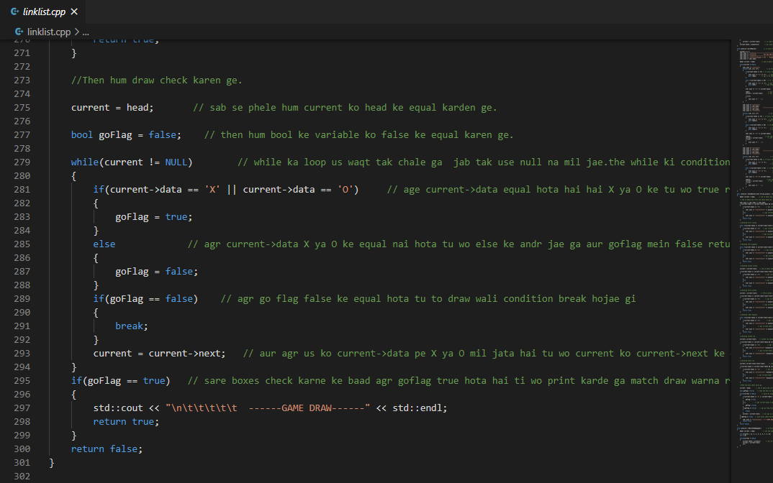

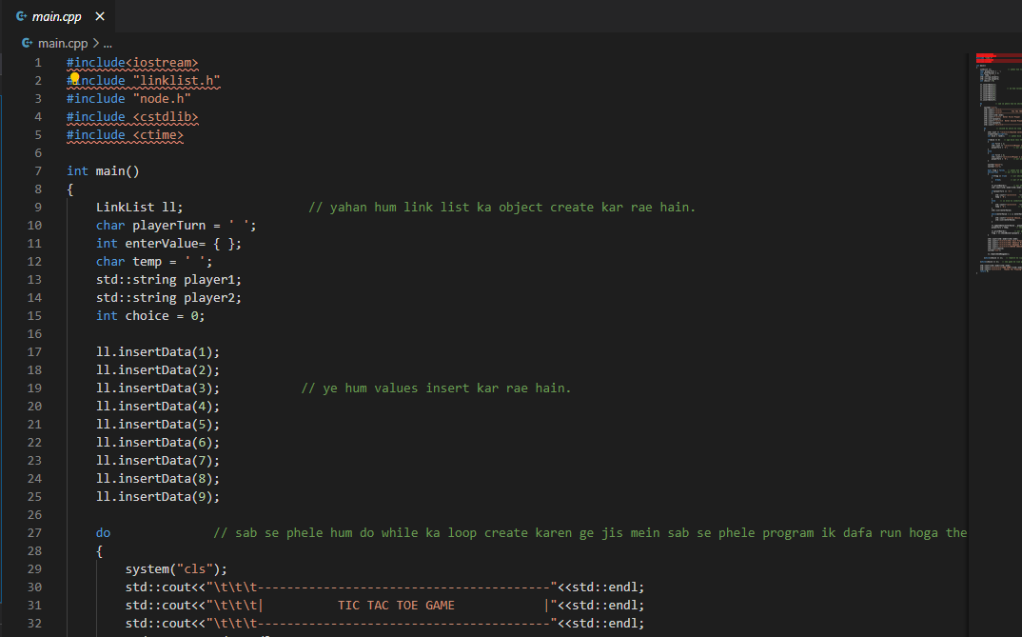

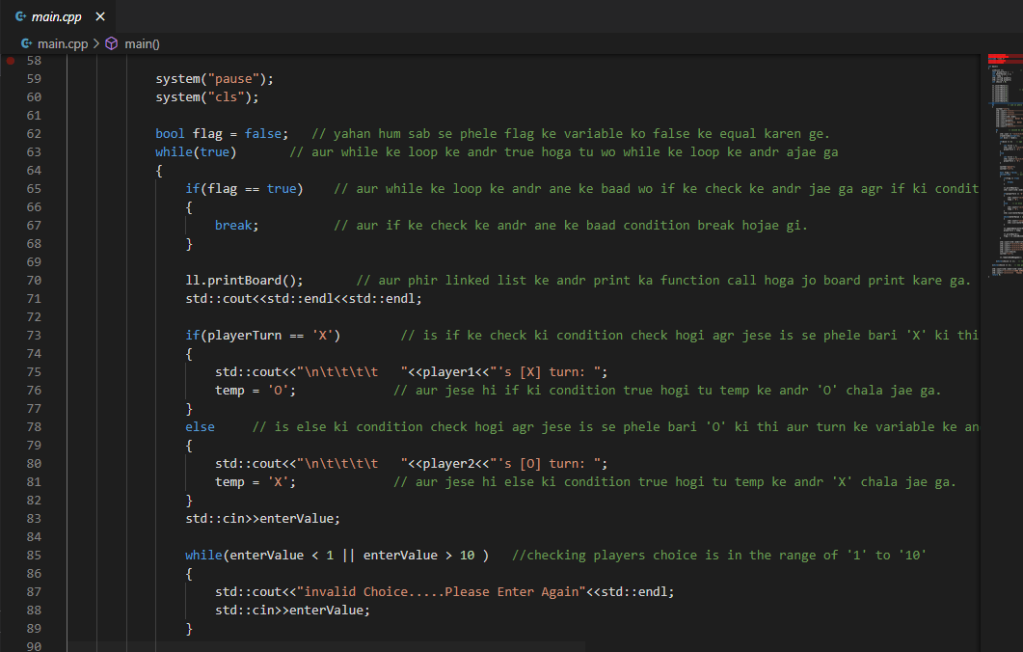

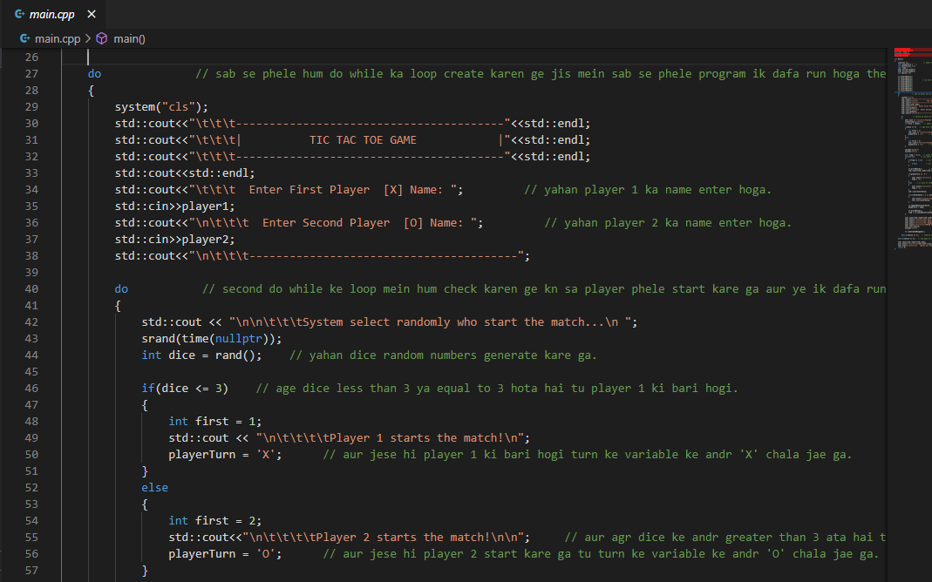

**DEMO**

